**Lesson 3 Demo 1**

**Configuring a Kubernetes Cluster**



Steps to be followed:

1. Setting up the master node and configuring the cluster
2. Joining the worker nodes to the cluster
3. Verifying the nodes in the cluster

**Step 1: Setting up the master node and configuring the cluster**

* 1. Run the following command to initiate kubeadm:

***sudo kubeadm init --pod-network-cidr=192.168.0.0/16***

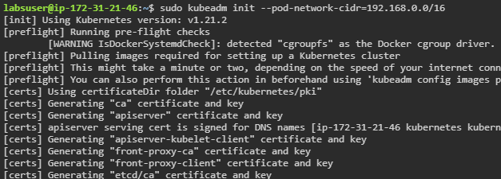

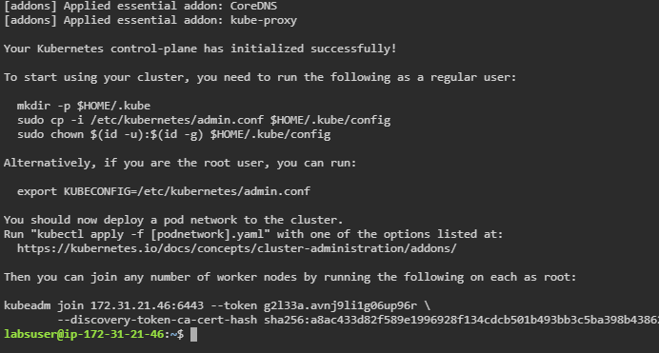

* 1. Copy the output command for joining the worker nodes to the cluster and save it

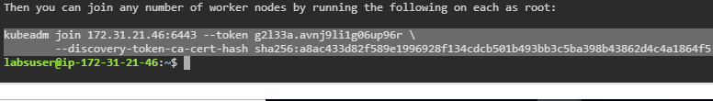

* 1. Run the following commands on the master node to allow non-root users to access and use **kubeadm:**

***mkdir -p $HOME/.kube***

***sudo cp -i /etc/kubernetes/admin.conf $HOME/.kube/config***

***sudo chown $(id -u):$(id -g) $HOME/.kube/config***

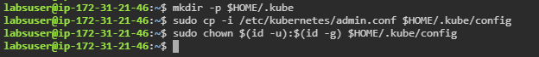

* 1. Run the following command to configure kube-proxy addon **Calico**:

***kubectl apply -f \***

***https://docs.projectcalico.org/v3.8/manifests/calico.yaml***

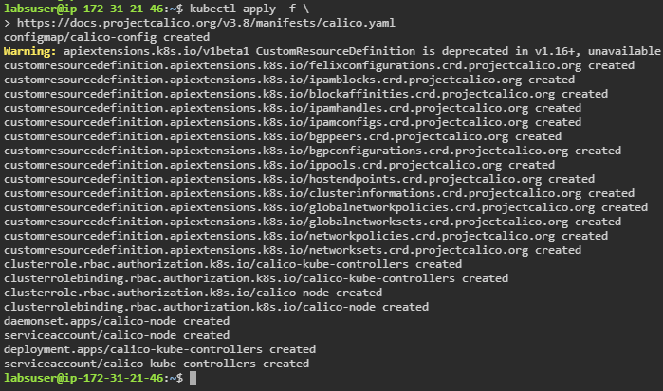

* 1. Verify the cluster setup by running the following commands:

***kubectl get nodes***

***kubectl get namespaces***

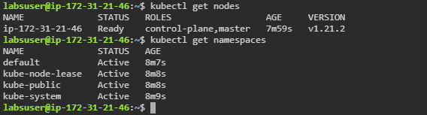

**Step 2: Joining the worker nodes to the cluster**

1. Click on **Worker 1** and **Worker 2** tabs on the lab window to open these nodes in new browser tabs

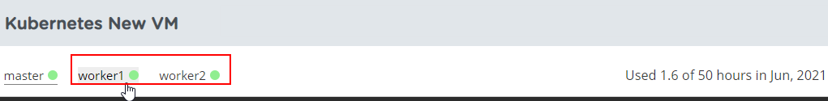

1. Go to **Worker1** node and run the ***kubeadm join*** command copied in **Step 1.2** to join this node as a worker node to the cluster

***sudo kubeadm join 172.31.21.46:6443 --token jnxnb7.qb30xonm53r18pun \***

***--discovery-token-ca-cert-hash sha256:ee6630aecec5854623ae6f260e24b12989f096be58a94570790c4cef6049a004***

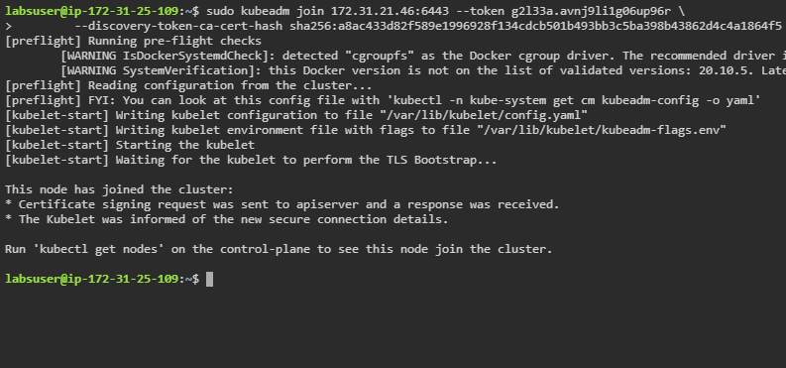

| **Note:** In case you need to find your unique token, run the command **sudo kubeadm token create --print-join-command** |
| --- |

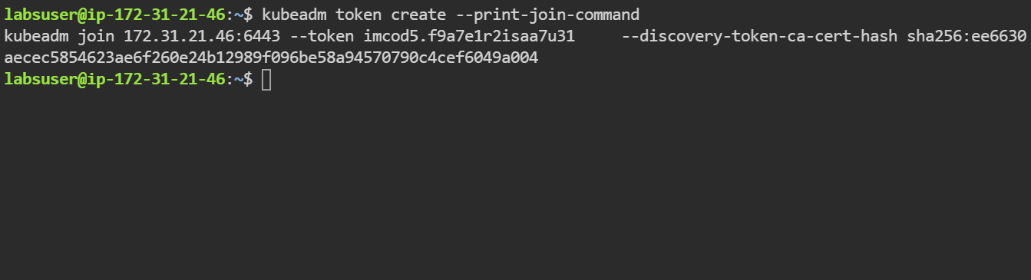

1. Go to **Worker2** node and repeat **Step 2.2** to join this node as a worker node to the cluster

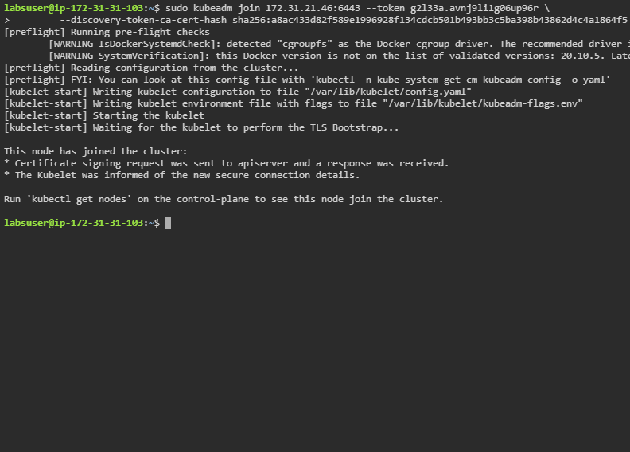

**Step 3: Verifying the nodes in the cluster**

1. Navigate to the **master node** tab and verify the nodes that are added to the cluster

***kubectl get nodes***

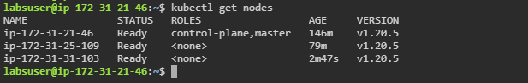

| **Note:** The cluster is properly created only when the nodes are in **Ready** status. |
| --- |